MAINTENANCE PLANNING FOR HAAS ST-10 CNC LATHES IN THE COVID-19 PANDEMIC ERA BASED ON INTERVAL TIME MAINTENANCE

Sumar Hadi Suryo¹⁾
Department of Mechanical Engineering, Diponegoro University, Semarang, 1269, Indonesia¹⁾

Abstract CNC Lathes are machines operated by a computer system used for various production processes, such as metal spinning, parts reclamation, woodturning, thermal spraying, glass-working, etc. These machines utilize a closed-loop system to detect errors via an alarm code automatically. CNC Lathes are one of the production machines with its operations inseparable from maintenance for maximum performance. This process is carried out by machine operators and technicians in the maintenance field. During the Covid-19 pandemic, maintenance policies remained the same, even though the production intensity changed under normal conditions. Therefore, this study determined the right maintenance planning strategy for CNC HAAS ST-10 from 6 to 8 working hours during the pandemic.

Keywords: CNC Lathe, Covid-19, Maintenance, Time Interval

1. Introduction
CNC Lathes are machines operated by a computer system and used for various production processes. These machines apply a closed-loop system that detects errors automatically via an alarm code [1]. One of the activities carried out by the manufacturing industry is machine maintenance, which is important to keep the engine in good condition for adequate performance [2]. Proper maintenance can keep the machine in top condition and reduce the costs of making repairs. Maintenance on this CNC Lathe machine is divided into preventive and curative.
Preventive maintenance is associated with the daily and monthly cleaning of the machine to eradicate the possibility of repairing or replacing the components due to work intensity, component life, mechanical and electrical conditions, and the tolerance of the resulting tensions. The maintenance carried out includes the lubrication of machine parts, such as slideway, coolant, hydraulic, and gearbox/spindle. Others include inspecting the machine control system to prevent overheating, cooling before and after use, cleaning, and checking the mechanical condition.

* Corresponding author. Email:
sumarhs.undip@gmail.com
Published online at http://jemis.ub.ac.id
Copyright © 2022 DTI UB Publishing. All Rights Reserved
Several maintenance policies were still carried out during the pandemic, even though the production intensity differed under normal conditions. Therefore, it is necessary to carry out a special strategy for maintenance, especially for the HAAS ST10 CNC lathe, which is one of the most common types manufactured in the United States of America [3].

2. Basic Theory

A. CNC Lathe Machine
A CNC Lathe is a machine tool used for various production processes assisted by a Computer Numerical Control (CNC). Companies use this machine because it is precise and faster producing quantity and quality outputs. Although the CNC lathe has the same parts as a conventional type in terms of shape and function, the machine parts are operated automatically via a monitor.

Fig 2.1 shows the image of the HAAS ST10 CNC lathe.
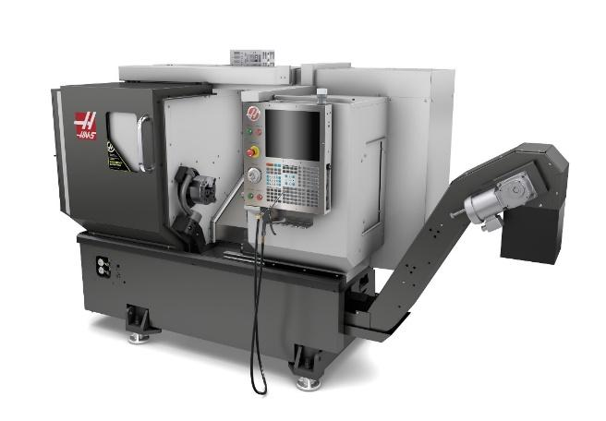
Fig 2.1 HAAS ST10 CNC Lathe
B. Maintenance
Maintenance and reliability are important for the proper functioning of a machine and to ensure it is always in standard conditions for optimum performance. Therefore, to achieve stability, maintenance, and reliability, it is necessary to have a plan and strategy of action.

There are two categories of maintenance, namely Preventive and Corrective or Breakdown. Preventive maintenance is carried out before failure or damage occurs to a system to keep it functioning in its prime [4]. It is also of two types, periodic or time-based and predictive or condition-based. Time-based maintenance is carried out based on analyzing failed occurrences within a period or interval. Meanwhile, condition-based maintenance is carried out based on the analysis of the machine’s condition. Preventive maintenance can be carried out with Condition Based Maintenance (CBM), assuming the implementation is effective, otherwise Time-Based Maintenance (TBM) is conducted.

After a machine failure, corrective maintenance is performed to restore the engine's performance to its original state. The costs incurred tend to be cheaper than the total amount for preventive maintenance. Sometimes it is even greater, especially when the machine production process is disrupted, leading to losses [5]. Therefore, to plan the minimum maintenance cost, it is necessary to consider the intensity of preventive and breakdown / corrective maintenance. The graph of the maintenance cost relationship is shown in Fig 2.2.

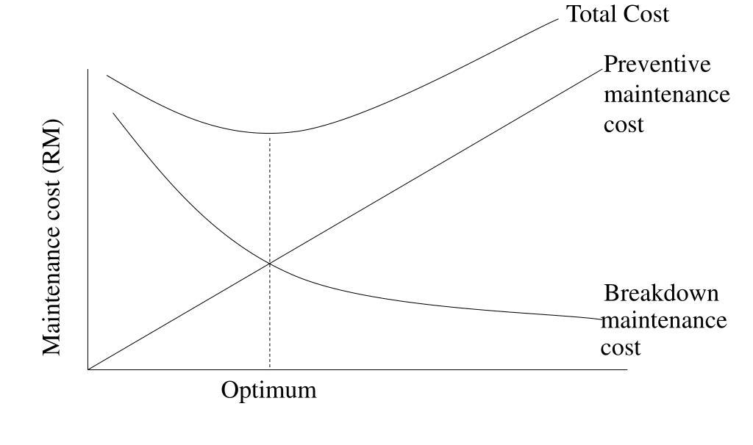
Fig 2.2: Relationship maintenance costs

C. Maintenance in Pandemic Era
The policies implemented by the Indonesian government during the pandemic caused some companies to experience a reduction in working hours, thereby leading to a decreased production process. This resulted in a decrease in the intensity of use of the machines, such as CNC lathes. The pandemic prompted companies to adjust the capacity of using the machine and maintenance time interval [6].

3. Research Methods
The method in this research starts from the literature study, data collection, data analysis and discussion, and conclusions. Literature studies are conducted by searching for previous studies on CNC machine maintenance and its strategies from reliable sources. The data collection method was used to gather data about the specifications and maintenance systems of the HAAS ST-10 CNC lathe. This stage also determined the time intervals for several maintenance techniques performed by companies, especially in manufacturing under normal and pandemic conditions.

Data analysis and discussion were carried out by analyzing maintenance strategies adapted during the pandemic based on the intensity of using machines, especially the HAAS ST-10 CNC lathe in the manufacturing industry in Indonesia. The conclusion contains the summary results obtained from data analysis and discussion conducted.

4. Analysis & Discussion
HAAS ST-10 machine is an American-made CNC lathe with high rotation capacity and power. Its specifications are shown in Table 5.1.

Table 5.1 HAAS ST-10 CNC Lathe Specifications
No | Parameter | Specifications
1 | Volume | 320 cm x 178 cm x 206 cm
2 | Weight | 3585.0 kg
3 | Spindle Speed | 6000 rpm
4 | Spindle Power | 11.2 kW.
5 | Feedrates | 1200 ipm
 |  | 1200 ipm
6 | Chucks | 165 mm
7 | Maximum Cutting Diameter | 356 mm
8 | Maximum Cutting Length | 406 mm
9 | Axis Motors | 14679 N on X
 |  | 14679 N on Z
10 | Max Torque | 102 Nm @ 1300 rpm

Based on the literature study and data collection conducted, HAAS CNC lathe maintenance ST-10 in normal conditions is shown in Table 5.2.

Table 5.2 HAAS CNC Lathe Maintenance
No | Item | Action | Time
1 | Filter | Inspect the hoses for cracking | 6 months
2 | Lubrication | Inspect grease reservoir level. | 2 weeks
3 | Electrical Cabinet | Clean vector drive air vents/filter. | Monthly
4 | Enclosure | Inspect way covers and lubricate. | Monthly
5 | Gearbox | Inspect the oil level. | Monthly
 |  | Replace the oil. | 1 week
6 | Spindle | Inspect lubrication tank level. | Monthly
7 | Hydraulics | Change the Hydraulic fluid | 6 months
8 | Tailstock | Grease the tailstock | 2 weeks
9 | Chucks | Grease the chuck jaws | 1 week
 |  | Clean the Chuck | Daily
10 | Bar feeders | Lubrication in the bar feed | 1 week
 |  | Lubrication in ballscrew, V-roller tracks, and rotation. (Bar 300) | 2 weeks

In terms of company policy during the pandemic, the working time changed from 8 to 6 hours, which affected the performance intensity of the machine. A new preventive maintenance strategy can be implemented by replacing hydraulic fluids every six months. Based on these data, the machine performance time can be calculated to determine the total working hours in a month, which takes 22 days to perform hydraulic fluid changes, is 1056 working hours under normal conditions. The calculation of the maintenance interval is shown in table 5.3.

Table 5.3 Normal Condition Maintenance Interval Time
No | Item | Action | Interval Time (hours)
1 | Filter | Inspect the hoses for cracking | 1056
2 | Lubrication | Inspect grease reservoir level. | 80
3 | Electrical Cabinet | Clean vector drive air vents/filter. | 176
4 | Way covers | Inspect way covers and lubricate. | 176
5 | Gearbox | Inspect the oil level. | 176
 |  | Replace the oil. | 40
6 | Spindle | Inspect lubrication tank level. | 176
7 | Hydraulics | Change the Hydraulic fluid | 1056
8 | Tailstock | Grease the tailstock | 80
9 | Chucks | Grease the chuck jaws | 40
 |  | Clean the Chuck | 8
10 | Bar feeders | Lubrication in the bar feed | 40
 |  | Lubrication in ballscrew, V-roller tracks, and rotation. (Bar 300) | 80

The calculation of alternative maintenance strategies in other methods during the pandemic is shown in Table 5.4.

Table 5.4 Maintenance in Pandemic Era
No | Item | Action | Interval Time (hours) | Time Work
1 | Filter | Inspect the hoses for cracking | 1056 | 8 months
2 | Lubrication | Inspect grease reservoir level. | 80 | 13 days
3 | Electrical Cabinet | Clean vector drive air vents/filter. | 176 | 29 days
4 | Way covers | Inspect way covers and lubricate. | 176 | 29 days
5 | Gearbox | Inspect the oil level. | 176 | 29 days
 |  | Replace the oil. | 40 | 6 days
6 | Spindle | Inspect lubrication tank level. | 176 | 29 days
7 | Hydraulics | Change the Hydraulic fluid | 1056 | 8 months
8 | Tailstock | Grease the tailstock | 80 | 13 days
9 | Chucks | Grease the chuck jaws | 40 | 6 days
 |  | Clean the Chuck | 8 | 1 day
10 | Bar feeders | Lubrication in the bar feed | 40 | 6 days
 |  | Lubrication in ballscrew, V-roller tracks, and rotation. (Bar 300) | 80 | 13 days

The intensity of engine performance from 8 to 6 hours affects the maintenance strategy applied. With the maintenance strategy, it is hoped that the capability of the system or machine will always be in working condition and reduce the costs incurred in maintaining the lathe.

5. Conclusion
In conclusion, the intensity of the machine's performance is directly proportional to the maintenance conducted on CNC lathe HAAS ST-10. The more preventive maintenance was conducted during the pandemic, the lesser the intensity of breakdown under normal conditions, thereby reducing machine maintenance costs.

REFERENCES

- Patil, Rajkumar Bhimgonda. 2017. Reliability analysis of CNC turning center based on the assessment of trends in maintenance data. International Journal of Quality & Reliability Management. 34 (9): 1616-1638.
- Schmidt, B., & Wang, L. 2018. Predictive maintenance of machine tool linear axes: A case from manufacturing industry. Procedia manufacturing. 17:118-125.
- Rodrigues, J. M. N. F. 2019. Analysis of the manufacturing process of bushings in landing gear maintenance.
- Sarfraz, M. S. 2017. Implementing a Preventive Maintenance Planning Model for Computer Numerical Control (CNC) Milling Machine. American Journal of Embedded Systems and Applications. 5 (6): 44-47.
- Kapuyanyika, M., & Suthar, K. 2018. To Improve the Overal Equipment Effectiveness of Wheel Surface Machining Plant of Railway Using Total Productive Maintenance. International Journal of Scientific Research in Science and Technology. 4 (5): 1860-1874
- Harja, H. B. 2019. Development of Real-Time Machine Tools Component Utilization Data Acquisition for developing Dynamic Model of Maintenance Scheduling.

